**Phase 3: Data Modelling & Relationships-**

## Standard & Custom Objects with Fields & Relationships-

## **STANDARD OBJECT-**

* **Contact (Citizen)- Standard Object**
  1. Represents the citizens who submit grievances or service requests.
  2. Relationships:
     1. Linked to **Case (Grievance)** → Citizen raising complaint.
     2. Linked to **Feedback** → Citizen who provides satisfaction rating.
     3. Linked to **Service Request** → Citizen requesting a service.

### **CUSTOM OBJECT-**

* **Grievance Category -**

1.To classify citizen grievances into categories such as Water, Electricity, Sanitation, Roads, Waste Management, Streetlights, etc.  
2.This ensures cases are **routed to the right department** and tracked efficiently.

3.Relatonships-

**Case → Category** *(Lookup)*

* Each case is tagged with a category (e.g., "Water").
* One category can apply to many cases (**One-to-Many**).

**Department → Category** *(Lookup)*

* Each category belongs to a government department.
* Example: *Water complaints → Water Department*.

**Category Name** (Text, Required)

* *Purpose:* The name of the grievance type.
* Example: "Road Repair"

**Expected Resolution Time** (Number)

* *Purpose:* Defines how many days are allowed to resolve grievances in this category.
* Example: 7

**Priority Level** (Picklist: Low, Medium, High, Critical)

* *Purpose:* Indicates urgency of grievances under this category.

**Case Active** (Checkbox, Default = True)

* *Purpose:* Indicates whether this grievance category is currently in use.

**Category ID** (Auto Number)

* Example: CAT-0001
* *Purpose:* Unique identifier for each grievance category.

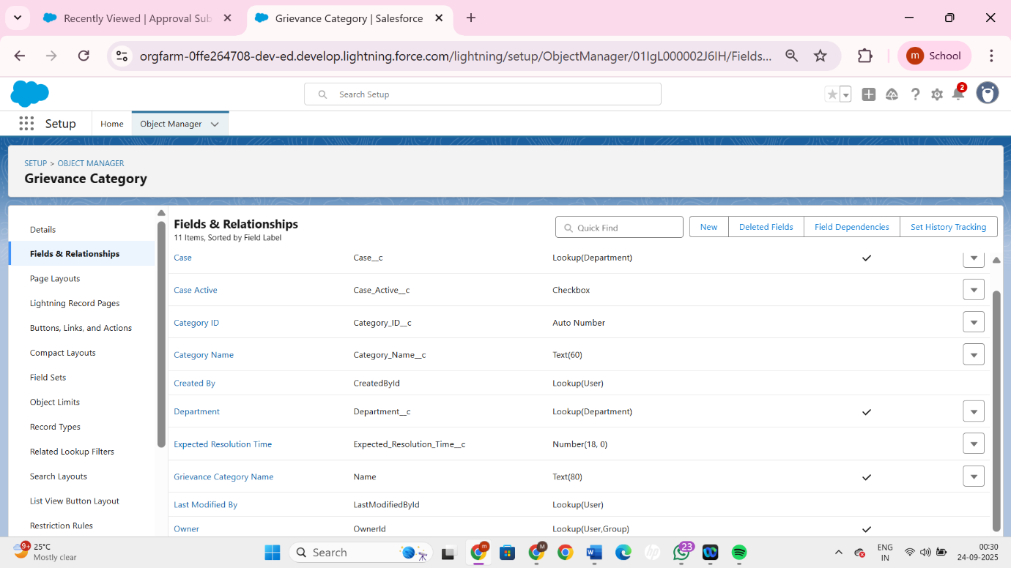

* **Department Object -**

1. Represents a government department responsible for handling grievances (e.g., Water Supply, Sanitation, Roads, Electricity).
2. Each grievance must be assigned to a department so that accountability is clear.
3. Relationships-

**Contact Person External (Lookup → Contact)** → Citizen-facing contact person for the department.

**Contact Person Internal (Lookup → User)** → Internal government officer linked to the department.

**Department Name (Text)** → Name of the government department (e.g., Water, Sanitation).

**Office Location (Text)** → Physical address or office location of the department.

**Resolution Supervisor (Lookup → User)** → Senior official responsible for supervising grievance resolution in that department.

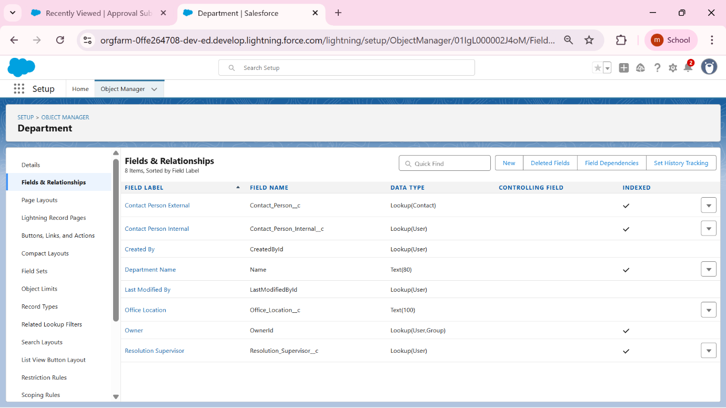

* **Service Request-**

1.Captures official citizen service requests such as new water connections, streetlight repairs, or license renewals. Enables tracking of service request lifecycle from submission to completion.

2. Relationship-

**Case (Lookup → Case)** → Links the service request to a related grievance case (if applicable).

**Citizen (Lookup → Contact)** → Identifies the citizen who raised the service request.

**Contact (Lookup → Contact)** → Internal/external contact person related to the request.

**Request Date (Date)** → Date when the service request was submitted.

**Request Type (Picklist)** → Defines the type of service requested (e.g., Water, Road, Electricity, Sanitation).

**Service Request Name (Text)** → Unique name/title of the service request.

**Status (Picklist)** → Current progress stage of the request.

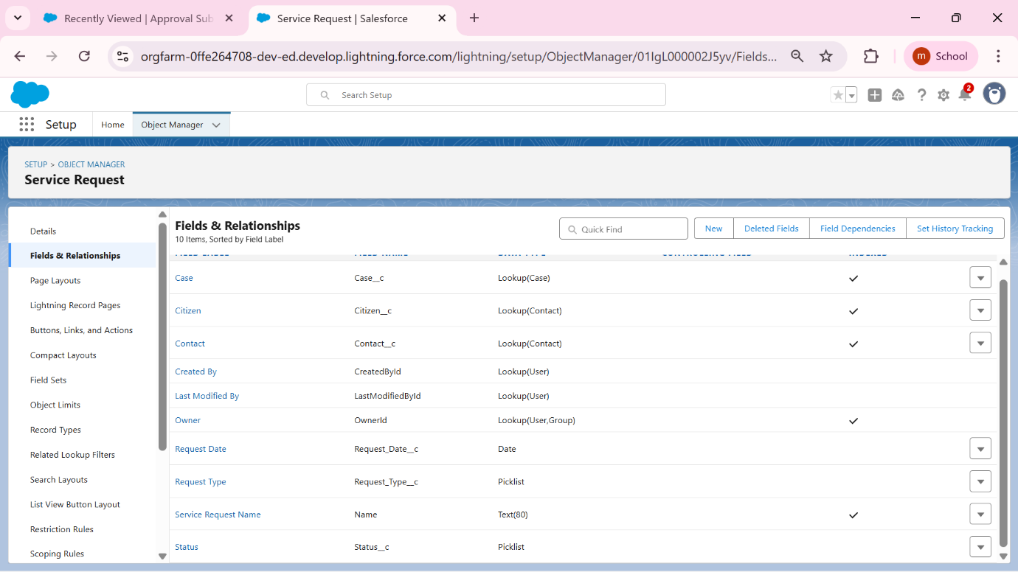

* **Complaint Escalations-**

1. Tracks the escalation stages of a grievance if not resolved within defined SLA timelines. Stores escalation levels, dates, and the officials or departments to whom the case was escalated.
2. Relationships-

**Case Reference (Lookup → Case)** → Links the escalation entry to the grievance case being escalated.

**Complaint Escalation Name (Text)** → Unique identifier or title for the escalation record.

**Escalated To (Lookup → User)** → Specific user/official the case was escalated to.

**Escalated To Dept (Lookup → Department)** → Department responsible after escalation.

**Escalation Date (Date/Time)** → The date and time the escalation occurred.

**Escalation Level (Picklist)** → Defines the escalation stage (Level 1 → Officer, Level 2 → Manager, Final → Top Authority).

**Resolution Deadline (Date/Time)** → The final deadline by which the grievance must be resolved post-escalation.

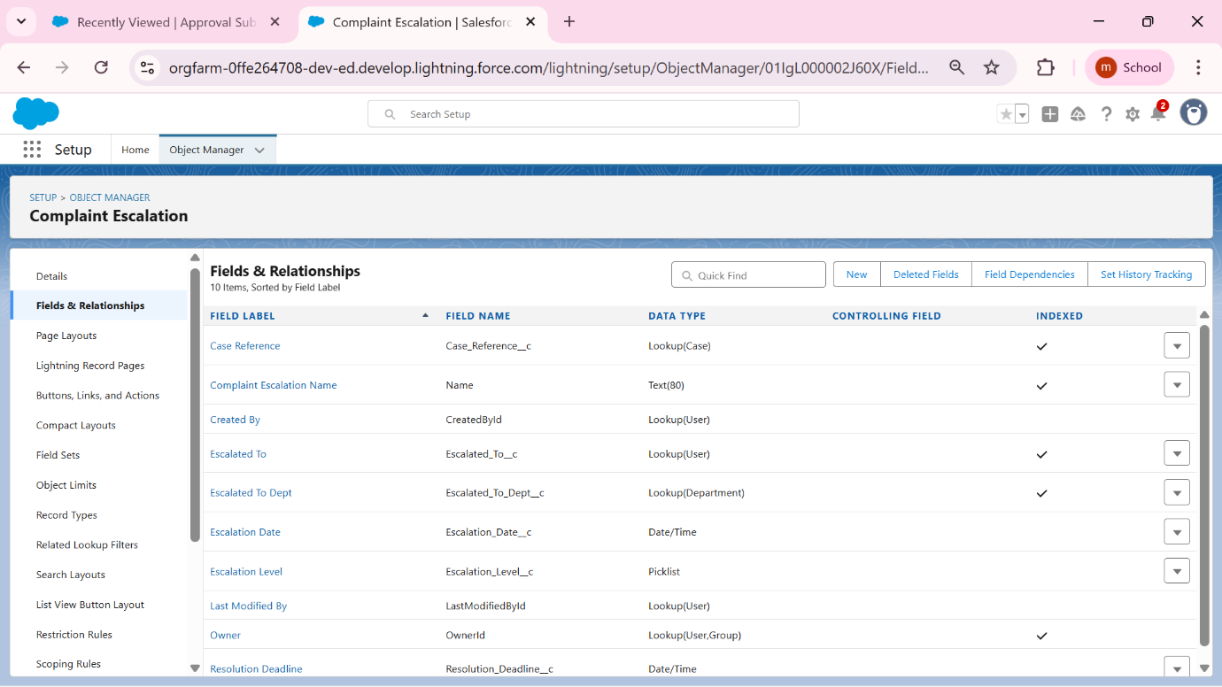

* **Citizen Feedback-**

1. Stores feedback and satisfaction ratings provided by citizens after their grievance or service request has been resolved. Helps measure service quality and accountability.
2. Relationships-

**Citizen (Lookup → Contact)** → Identifies the citizen who submitted the feedback.

**Citizen Feedback Name (Text)** → Title or unique name for the feedback entry.

**Comments (Long Text Area)** → Detailed feedback, remarks, or suggestions provided by the citizen.

**Feedback ID (Auto Number)** → Auto-generated unique identifier for each feedback record.

**Rating (Picklist)** → Citizen’s satisfaction rating (e.g., Poor, Average, Good, Excellent).

**Related Case (Lookup → Case)** → Links the feedback to the grievance case it is about.

**Submitted On (Date/Time)** → The exact date and time when the citizen submitted the feedback.

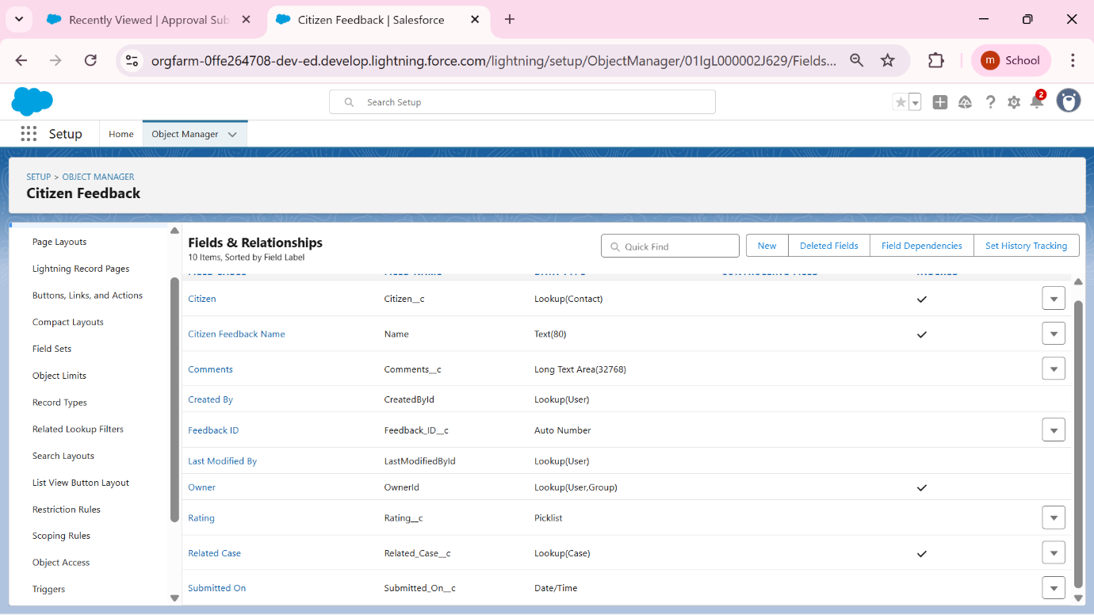

* **Public Announcement-**

1. Used to publish public notifications or announcements to citizens, such as service disruptions, upcoming maintenance, or awareness campaigns. Helps improve communication and transparency.
2. Relationships-

**Department (Lookup → Department)** → Links the announcement to a specific department responsible for publishing it.

**Message (Long Text Area)** → The detailed content of the announcement (instructions, alerts, or updates).

**Public Announcement Name (Text)** → Unique identifier or name for the announcement record.

**Title (Text)** → A short, clear headline describing the announcement (e.g., *“Water Supply Disruption”*).

**Valid From (Date)** → Start date from which the announcement becomes visible to citizens.

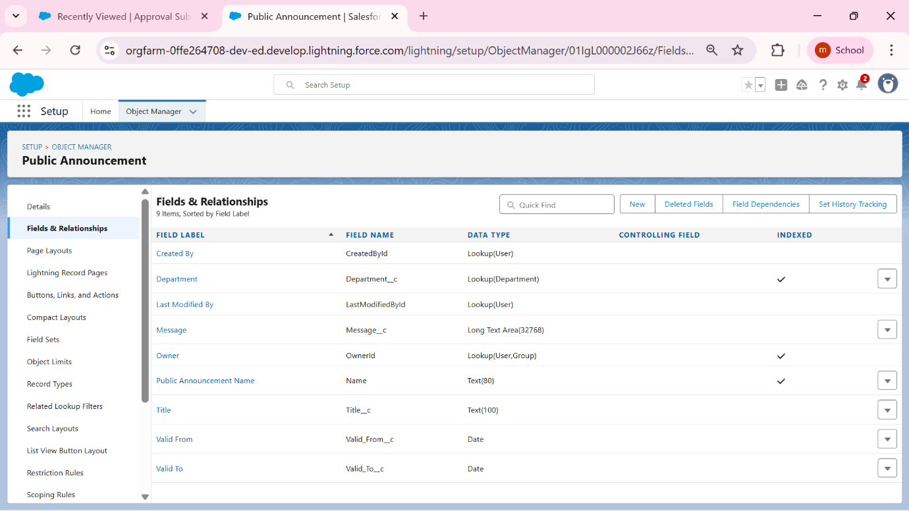

* **Service Area-**

1. Defines geographical boundaries (wards, zones, pin codes) for grievance reporting and resolution. Useful for assigning complaints to departments based on citizen location.
2. Relationships-

**Assigned Department (Lookup → Department)** → Links the service area to the responsible department (e.g., Sanitation, Water, Electricity).

**Pin Code (Text)** → The postal pin code associated with the service area.

**Service Area Name (Text)** → The unique name/identifier for the service area (e.g., “Ward 12 – North Zone”).

**Ward Name (Text)** → The municipal ward under which this service area falls.

**Zone (Text)** → The broader zone within the city that groups multiple wards or service areas (e.g., “East Zone”).

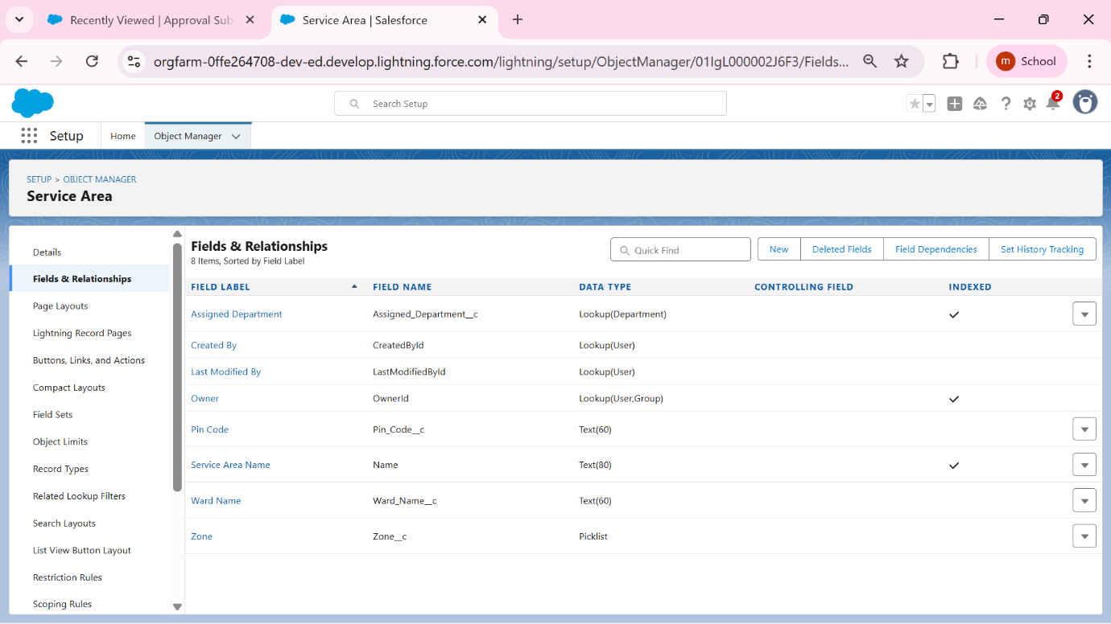

* **Service Area-**

1. This is the heart of the GrievEase app, where every citizen’s complaint is logged and tracked.

Example Record Types for Grievance Case

1. Citizen Complaint → Normal grievance submitted by a citizen.
2. Urgent Complaint → High-priority grievance (strict SLA/escalation).
3. Service Request → Not a complaint, but a request for service (e.g., repair).
4. Relationship-

**Contact (Lookup → Contact)** → Connects the grievance to the citizen who raised it.

**Department (Lookup → Department)** → Assigns responsibility to the relevant government department.

**Grievance Category (Lookup → Grievance Category)** → Classifies the complaint type for SLA and reporting.

**Record Type (RecordTypeId)** → Differentiates cases as Citizen Complaint, Urgent Complaint, or Service Request.

**Service Area (Lookup → Service Area)** → Maps the grievance to its geographic location (ward/zone).

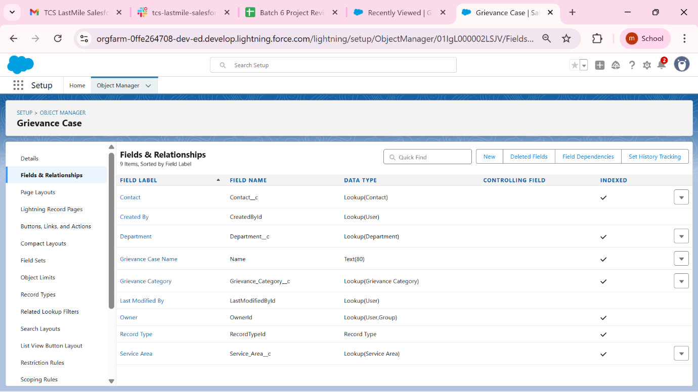

## RECORD TYPES AND PAGE LAYOUTS-

* 1. **Grievease Case-**
* **Citizen Complaint** → Standard grievances raised by citizens (e.g., road damage, water leakage).

**Key Fields:** Citizen (Contact), Department, Grievance Category, Service Area, Description, Owner.

**Related Lists:** Escalation History, Citizen Feedback.

* **Urgent Complaint** → High-priority issues requiring immediate attention (e.g., power outage, health emergency).

**Key Fields:** Citizen, Department, Category, Service Area, Priority (auto “High”), SLA Due Date, Status.

**Related Lists:** Escalation History.

* **Service Request** → Requests for authorized services instead of complaints (e.g., new water connection, streetlight installation).

**Key Fields:** Citizen, Department, Record Type, , Service Area.

**Related Lists:** Feedback.

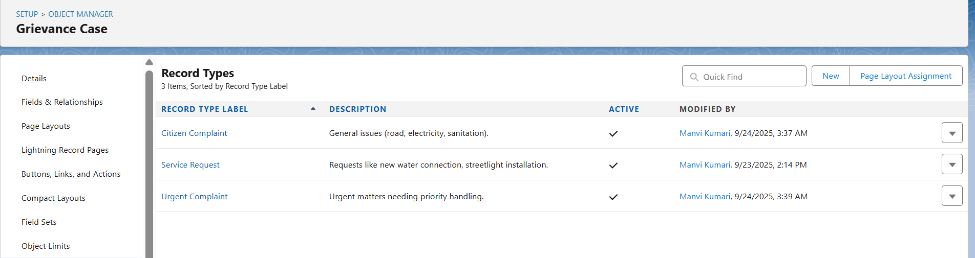

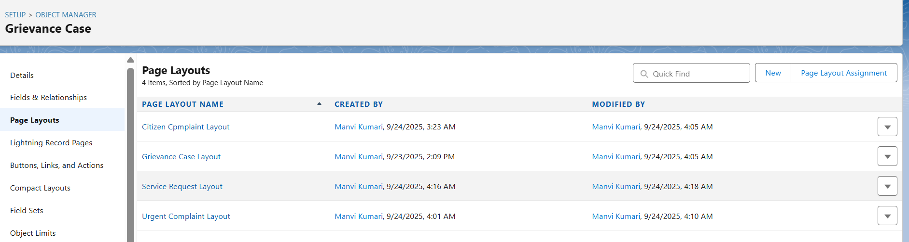

**2.Service Request-**

**. New Installation**

**• New Installation →** Request for setting up a new service/utility (e.g., new water connection, streetlight installation).  
Key Fields: Citizen (Contact), Department, Request Type = New Installation, Service Area, Request Date, Status, Owner.  
Related Lists: Citizen Feedback, Files/Attachments.

**Repair/Maintenance**

**Repair/Maintenance →** Fixes or maintenance for existing services (e.g., leakage, streetlight not working, breakdown)

Key Fields: Citizen, Department, Request Type = Repair/Maintenance, Service Area, Request Date, Status, Priority, Owner.  
Related Lists: Escalation History, Citizen Feedback**.**

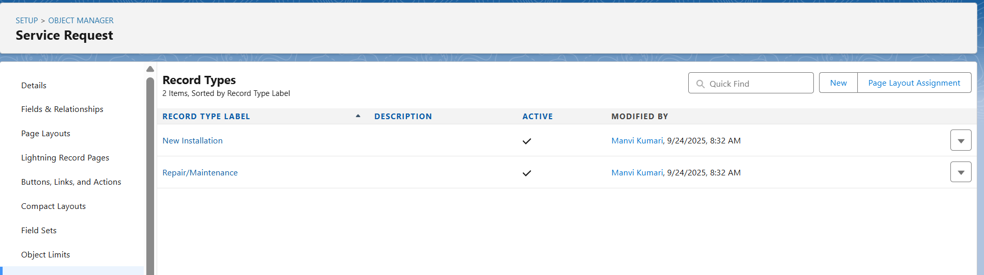

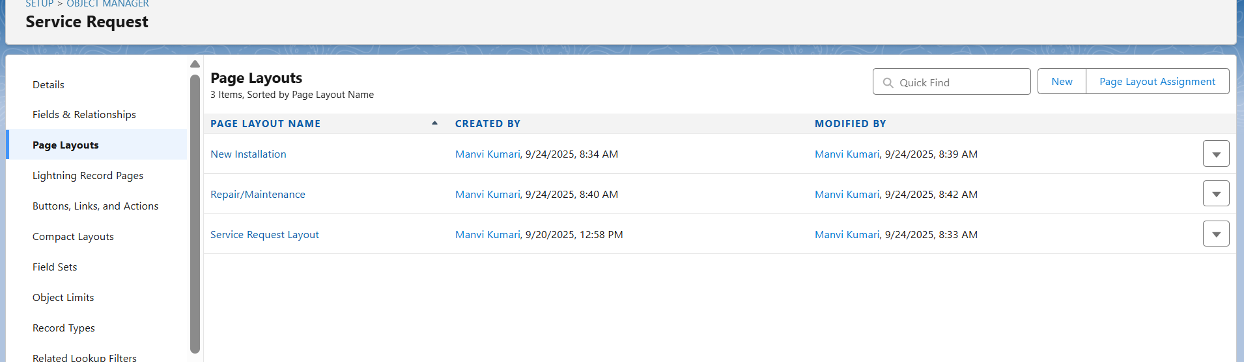

**3. Complaint Escalation**

* Level 1 Escalation → Case escalated to Department Manager for departmental resolution.  
  Key Fields: Case Reference, Escalated To Dept, Escalated To (User), Escalation Date, Escalation Level = *Level 1*.  
  Related Lists: Case History, Resolution Deadline.
* **Level 2 Escalation →** Escalation to Chief Grievance Officer if not resolved at Level 1.  
  **Key Fields:** Case Reference, Escalated To Dept, Escalated To (C.G.O.), Escalation Date, Escalation Level = *Level 2*, Resolution Deadline.  
  **Related Lists**: Case History, Citizen Feedback.

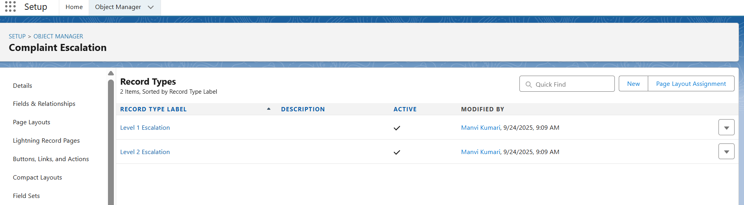

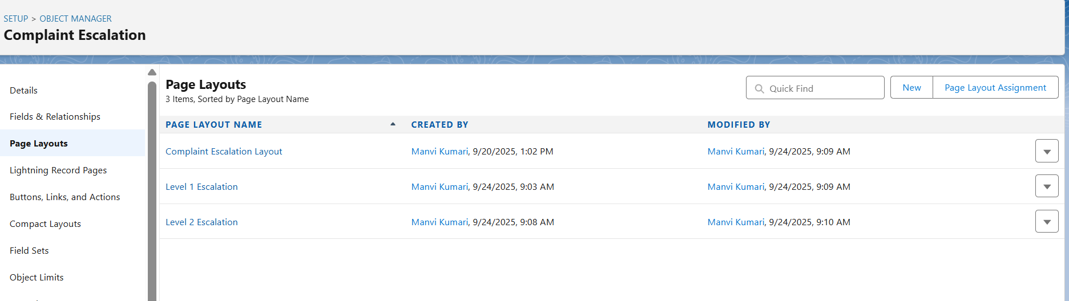

**4. Citizen Feedback**

* **Positive Feedback →** Citizens acknowledging satisfaction with resolution or appreciating service.  
  Key Fields: Citizen (Contact), Related Case, Rating = *Positive*, Comments.  
  Related Lists: Related Case.
* **Negative Feedback →** Citizens expressing dissatisfaction or unresolved issues requiring follow-up.  
  Key Fields: Citizen, Related Case, Rating = *Negative*, Comments.  
  Related Lists: Related Case, Escalation History.

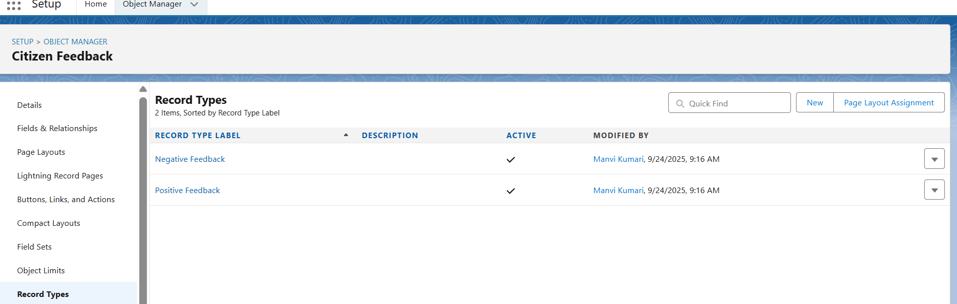

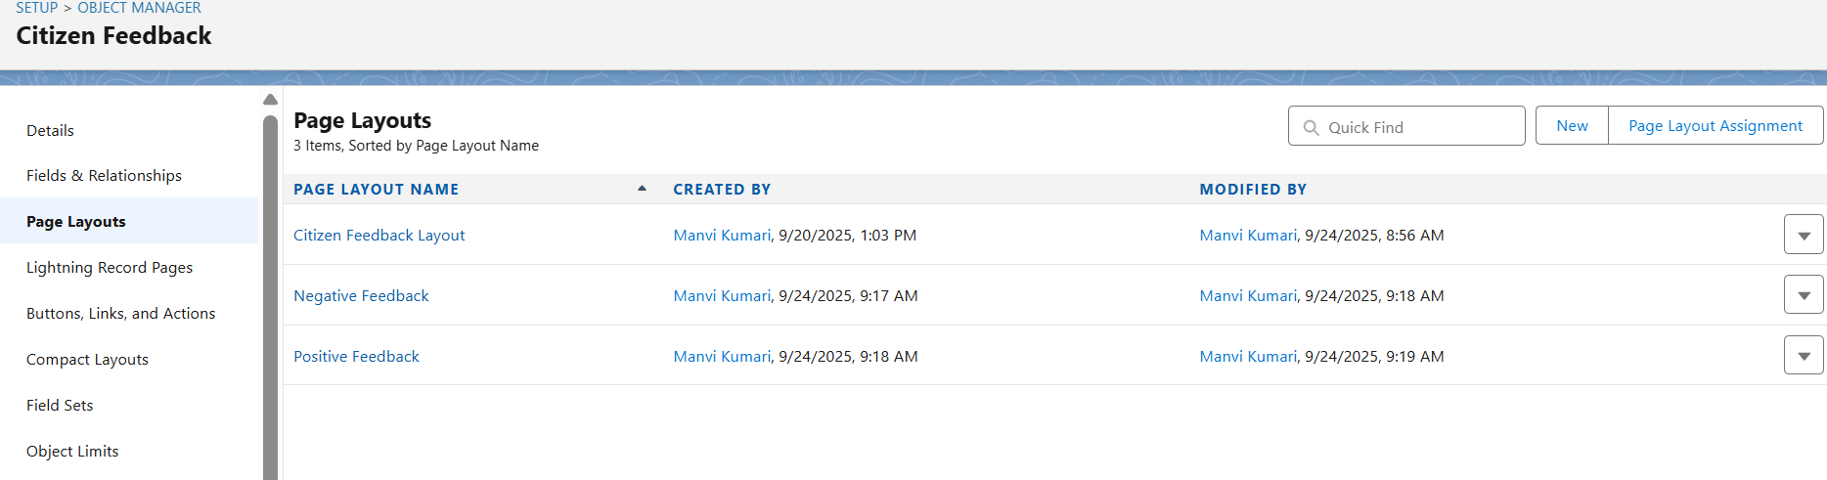

**5. Public Announcement**

* **General Notice →** Regular public information such as guidelines, updates, reminders.  
  Key Fields: Title, Department, Message, Valid From, Valid To.  
  Related Lists: Files, Citizen Acknowledgements.
* **Emergency Notice →** Urgent alerts requiring immediate citizen attention (e.g., water cut, power outage, sanitation emergency).  
  Key Fields: Title, Department, Message, Valid From, Valid To, Priority.  
  Related Lists: Files, Related Service Area.
* 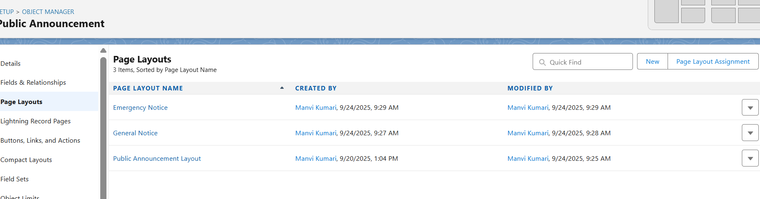
* 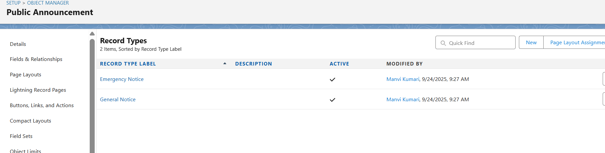

### COMPACT LAYOUTS-

* Steps to Create Compact Layouts in Salesforce
* Go to Setup (⚙️ in the top right → Setup).
* In Quick Find, type Object Manager and click it.
* Select the object (e.g., *Grievance Case*).
* In the left panel, click Compact Layouts.
* Click New → enter a name (e.g., *Grievance Case Highlights*).
* Select up to 10 fields that should appear in the mobile highlights panel / Lightning record header.
* Save.
* Back in Compact Layouts, click Compact Layout Assignment → Edit Assignment → set your new compact layout as the Primary Layout.
* Save.

COMPACT LAYOUTS FOR GRIEVEAE-

* **Grievance Case** → Case Name, Status, Priority, Department, Citizen.
* **Complaint Escalation** → Escalation Name, Level, Escalated To, Department, Deadline.
* **Citizen Feedback** → Feedback Name, Rating, Related Case, Submitted On.
* **Public Announcement** → Title, Valid From, Valid To, Department.
* **Service Area** → Service Area Name, Zone, Ward Name, Pin Code. 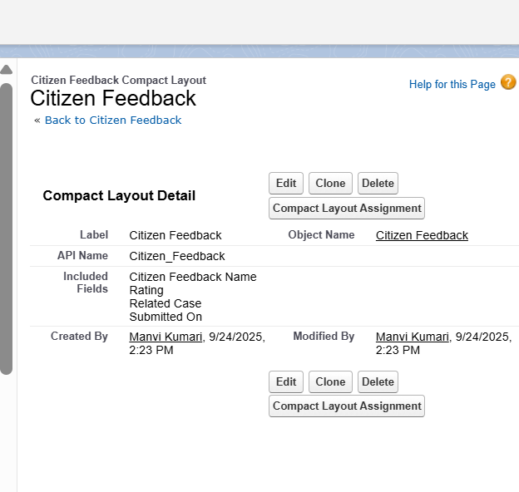

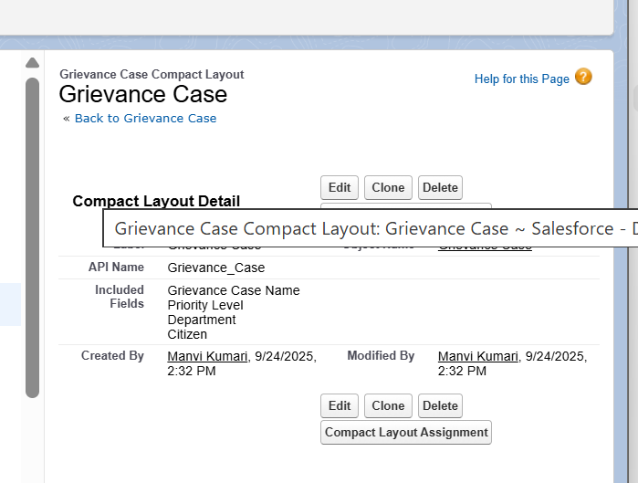

### SCHEMA BUILDER

* **Grievance Case → Grievance Category**: Each grievance is classified under a category.
* **Grievance Case → Department**: Complaints are assigned to the responsible department.
* **Grievance Case → Service Area**: Each grievance is tied to a location/ward.
* **Grievance Case → Contact (Citizen)**: The citizen who raised the grievance.
* **Grievance Case → Escalation History**: One case can have multiple escalation records.
* **Grievance Case → Citizen Feedback**: Citizens provide feedback after resolution.
* **Service Request → Department**: Service requests are handled by departments.
* **Service Request → Contact (Citizen)**: Citizen requesting the service.
* **Public Announcement → Department**: Announcements are issued by departments.
* **Service Area → Department**: Areas are mapped to their responsible departments.
* **Escalation History → User/Department**: Tracks who the case was escalated to.

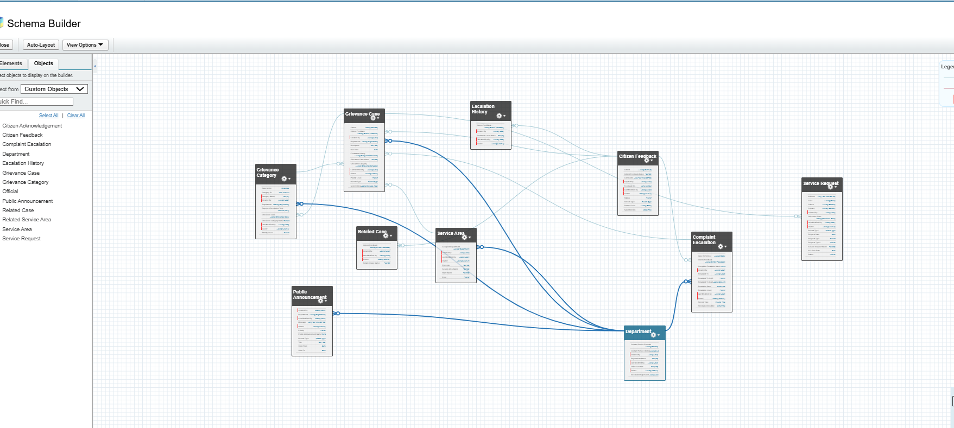

## LOOKUP VS MASTER-DETAIL VS HIERARCHICAL

**Lookup**

* **Grievance Case ↔ Citizen (Contact)** → Lookup (a case is linked to a citizen, but citizen exists independently).
* **Grievance Case ↔ Department** → Lookup (cases reference departments without ownership).
* **Grievance Case ↔ Service Area** → Lookup (area info is referenced, not dependent).
* **Service Request ↔ Citizen (Contact)** → Lookup (citizen may request multiple services).
* **Public Announcement ↔ Department** → Lookup (announcement is issued by a department).

**Master-Detail**

* **Grievance Case ↔ Escalation History** → Master-Detail (a grievance can have multiple escalation records, but escalation cannot exist without the grievance).
* **Grievance Case ↔ Citizen Feedback** → Master-Detail (feedback is tied to a grievance and deleted if grievance is removed).

**Hierarchical**

* **User ↔ Escalation Manager** → Hierarchical (used for assigning escalations up the role chain, e.g., Agent → Manager → Chief Officer).

### JUNCTION OBJECTS

**. Create the Junction Object**

1. Go to **Setup → Object Manager → Create → Custom Object**.
2. Label: **Case–Department Mapping** (API Name: Case_Department_Mapping__c.
3. Save.

**2. Add Two Master-Detail Fields**

1. In the **junction object**, go to **Fields & Relationships → New**.
2. Choose **Master-Detail**.
   * First field → **Grievance Case** (points to Grievance Case object).
   * Save.
3. Repeat → Add another **Master-Detail** field.
   * Second field → **Department**.
   * Save.

Now, this junction object sits between **Grievance Case** and **Department**, allowing *many-to-many*.

**3. Add Related Lists**

1. Go to **Grievance Case Page Layout** → Add **Case–Department Mapping** related list.
2. Do the same for **Department Page Layout**.

## 